**Where Containers Are Stored**

**Step 1 : Check for the docker information**

# docker info

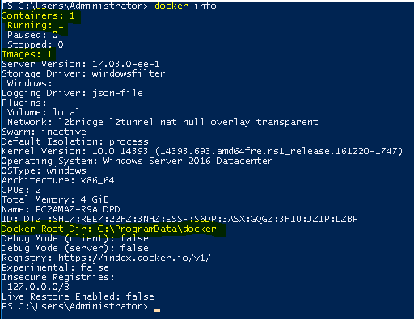

**Step 2 : Paste it to your File Explorer**

# C:\ProgramData\docker

**# // Enter**

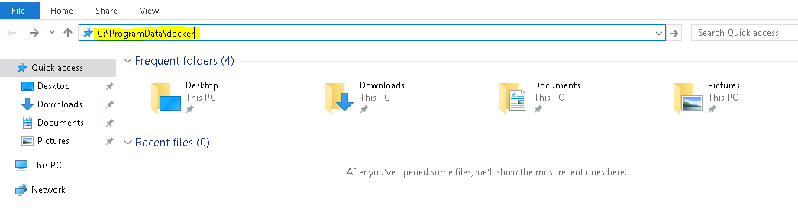

**Step 3 : Explore the Folder(Here you can se your Container)**

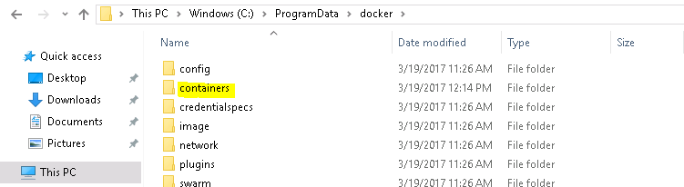

**Step 4 : This is your Container**

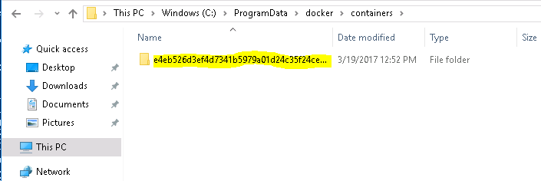

**Step 5 : List the running container**

# docker ps

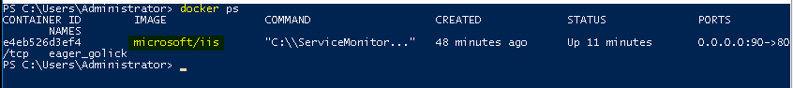

**Step 6 : Explore your container folder (You will get the json file)**

